LISYM (Library Management System)

PROJECT REPORT
Submitted by

Srijita Kumar (24BCI0113)
Kopal Joshi (24BCI0116)

Prepared For

DATABASE SYSTEMS (BCSE302P) -Lab PROJECT

Submitted To

Dr. Anand Bihari

School of Computer Science and Engineering



Abstract

The Smart Library Management System is a database-driven application developed to automate and simplify library operations, including book management, member registration, book issuance and returns, reservations, and fine management. Traditional library systems that depend on manual record-keeping often face challenges such as data redundancy, record inconsistencies, difficulty tracking book availability, and inefficient management of borrowing transactions. This project aims to overcome these limitations through a centralized, organized, and reliable system.

The application uses MySQL for database management, DBeaver for database development and administration, Python Flask for backend processing, and HTML, CSS, and JavaScript for the frontend interface. The database consists of interconnected tables for members, librarians, books, authors, publishers, categories, shelves, individual book copies, loans, fines, reservations, notifications, and audit logs. Primary keys, foreign keys, integrity constraints, and normalization principles are used to maintain data accuracy, establish relationships between entities, and reduce unnecessary data duplication.
The system provides essential functionalities such as maintaining book and member records, tracking individual book copies, managing issue and return transactions, identifying overdue books, recording fines, and handling reservations. SQL queries enable efficient retrieval of information, including available books, borrowing history, overdue loans, unpaid fines, and popular titles. Additional database features such as joins, views, stored procedures, triggers, indexes, and transactions support efficient data access, automate selected operations, and maintain consistency across related database updates. The system can also generate useful reports and analytics to help librarians monitor inventory, circulation activity, and outstanding fines.

The primary objective of this project is to improve the efficiency, accuracy, and accessibility of library operations while demonstrating the practical application of Database Management System concepts, including relational database design, entity relationships, normalization up to Third Normal Form (3NF), integrity constraints, transaction management, and query optimization. By integrating database functionality with a modular application architecture, the Smart Library Management System provides a structured and extensible solution for modern library administration, with scope for future enhancements such as role-based authentication, automated notifications, book recommendation mechanisms, barcode-based tracking, and advanced analytics.

Table of Contents
Contents
1. Introduction 4
2. Project SCOPE 4
3. Key Contacts and Stakeholders 4
4. Project Resource Requirements 4
4.1 Software Resource Requirements 4
5. ER Diagram 5
6. Tables and Constraints 6
7. SQL Implementation 11
8. Advanced SQL Implementation 22
10. Work break down 39
11. REVIEW EVALUATION 39

Introduction
Every educational institution requires an efficient system to manage its library resources, maintain book records, and provide students and faculty members with convenient access to learning materials. Traditional library management methods often involve manual record-keeping, which can lead to data inconsistencies, difficulty in tracking book availability, delays in issuing and returning books, and challenges in maintaining borrowing histories. The Smart Library Management System is designed to overcome these challenges by automating essential library operations through a centralized database. It uses a relational database management system to maintain information about books, authors, publishers, categories, physical book copies, library members, loans, reservations, and fines. By implementing SQL queries, constraints, views, stored procedures, functions, and triggers, the system aims to improve data integrity, simplify information retrieval, automate routine operations, and support efficient library administration. The system also incorporates database access control to protect information and restrict operations according to user privileges.

Project SCOPE
The Smart Library Management System aims to automate and streamline the following library operations:
- Book and Catalogue Management: Maintain records of books, authors, publishers, categories, ISBNs, and publication details for efficient catalogue management.
- Book Copy and Availability Tracking: Maintain individual physical book copies, track their accession numbers, and update their availability status when books are issued or returned.
- Member Management: Store and manage library member details, membership dates, and membership statuses while maintaining unique member records.
- Book Issuing and Return Management: Record book loans, issue dates, due dates, and return dates to monitor borrowing activities and identify overdue books.
- Reservation Management: Allow reservation records to be maintained for members waiting to borrow books and track reservation statuses.
- Fine Management: Maintain fine records associated with loans, calculate overdue durations, and track unpaid and paid fines.
- Advanced Querying and Reporting: Generate reports on overdue loans, borrowing histories, book inventory, popular books, member borrowing activity, and outstanding fines using joins, aggregate functions, subqueries, and ranking operations.
- Database Automation: Use views, stored procedures, user-defined functions, and triggers to simplify repetitive operations, perform calculations, and maintain consistency across related records.
- User Authentication and Access Control: Support controlled database access through administrator, librarian, and viewer roles. Website-level member registration and password-based login can be incorporated through a backend authentication system.
- Data Integrity and Security: Apply primary keys, foreign keys, unique constraints, transactions, and database privileges to reduce invalid data entry, maintain reliable records, and prevent unauthorized database operations.

Key Contacts and Stakeholders
Name | Registration Number | Phone Number/Email
Srijita Kumar | 24BCI0113 | 7709990391
Kopal Joshi | 24BCI0116 | 98202 59777

Project Resource Requirements

Software Resource Requirements
- Windows XP (Service Pack3)
- mysql
- HTML 5
- JavaScript
- PHP5.5
- Apache Web Server
- Rational Rose Enterprise Edition
- 2-Plan
- ArgoUML

ER Diagram
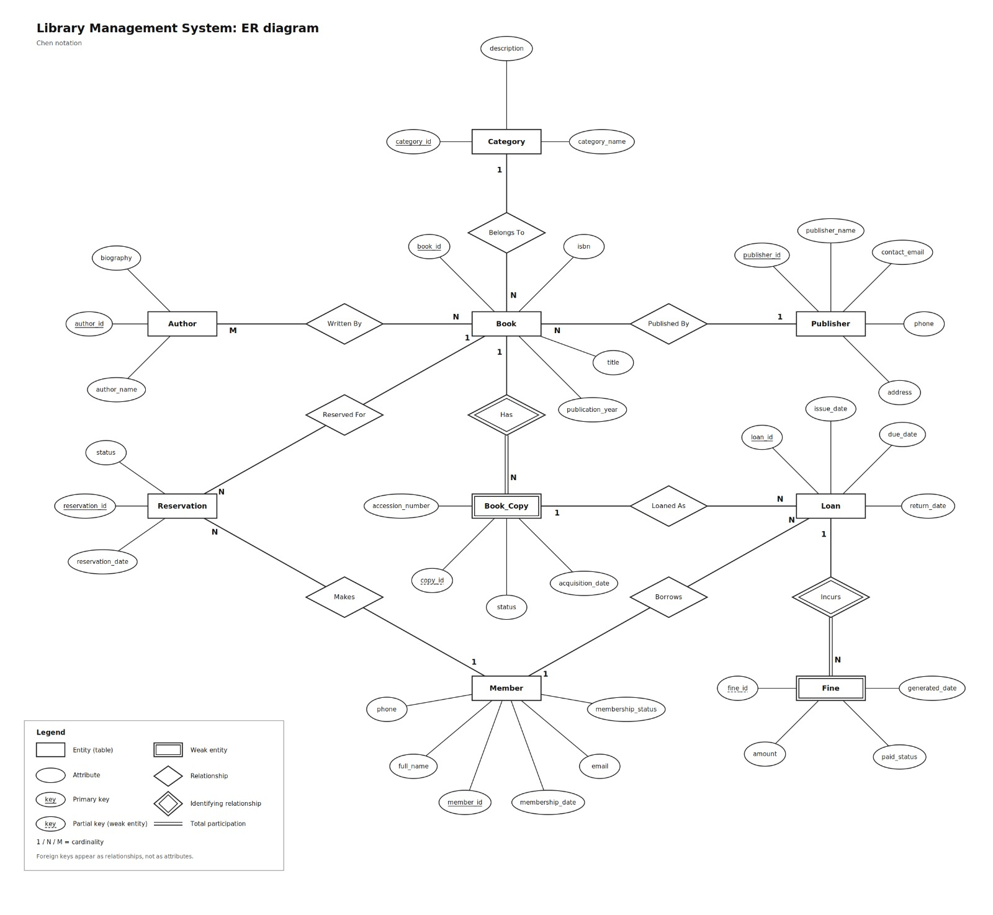

Tables and Constraints

The database consists of 11 tables: AUTHOR, BOOK, BOOK_AUTHOR, BOOK_COPY, CATEGORY, FINE, ISSUED_BOOKS, LOAN, MEMBER, PUBLISHER, and RESERVATION. These tables are designed to organize library information, minimize data redundancy, and maintain referential integrity through primary keys, foreign keys, and other constraints.
The database primarily follows Third Normal Form (3NF), provided that each table's attributes and dependencies satisfy the requirements of 1NF, 2NF, and 3NF. The exact normal form of each table must be confirmed against its actual column definitions and functional dependencies.

Table Name: author
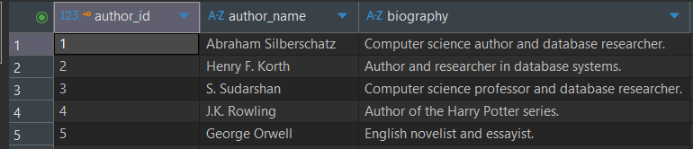

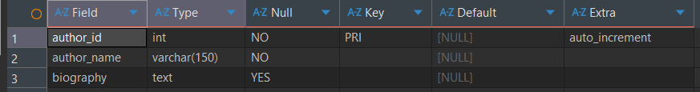

Table Name: book
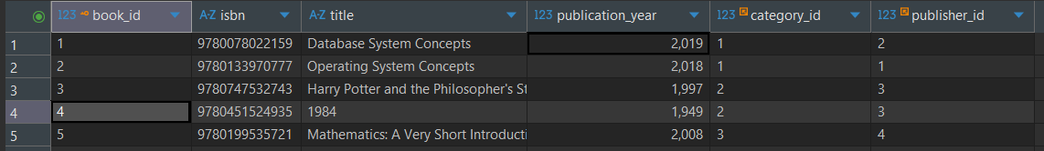

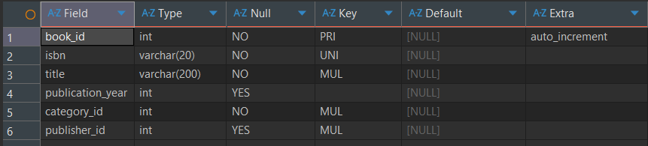

Table Name: book_author
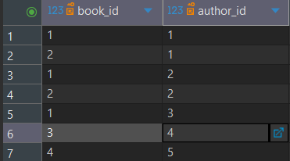

Table Name: book_copy
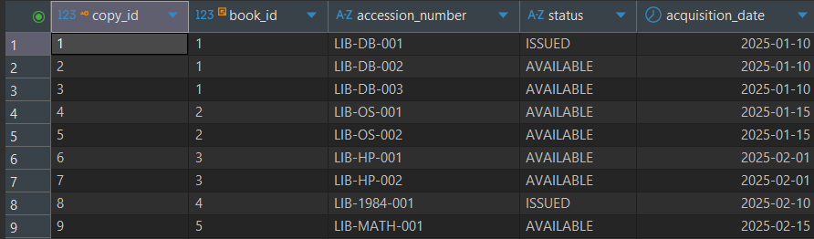

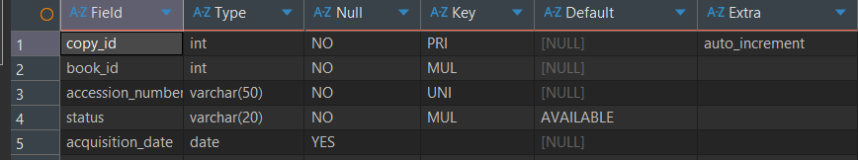

Table Name: category
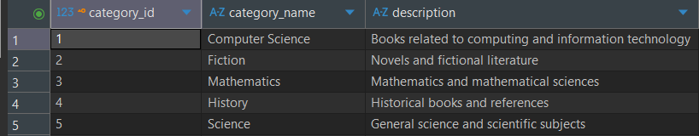

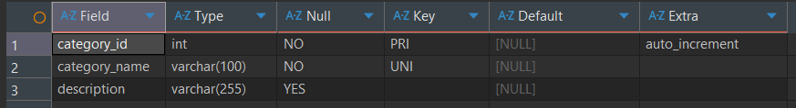
Table Name: fine


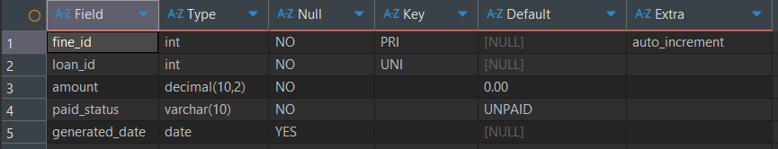

Table Name: issued_books
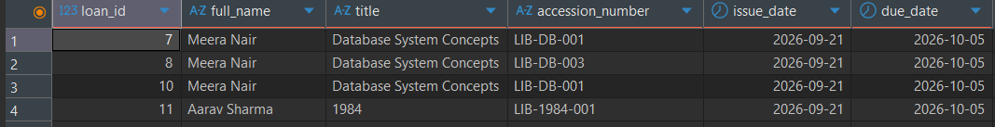

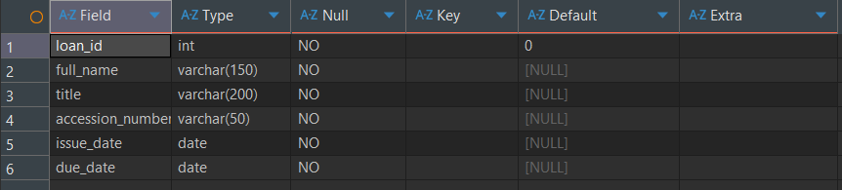

Table Name: loan
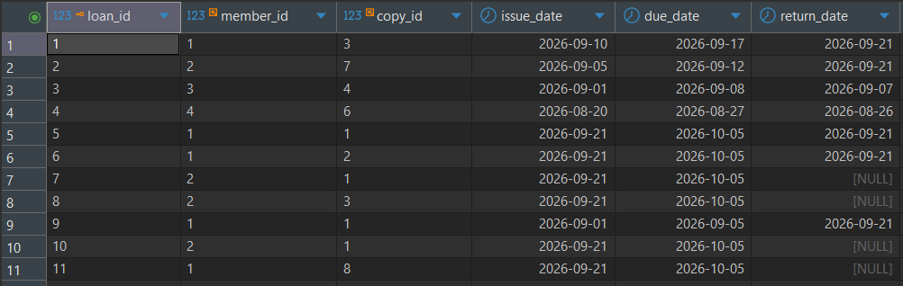

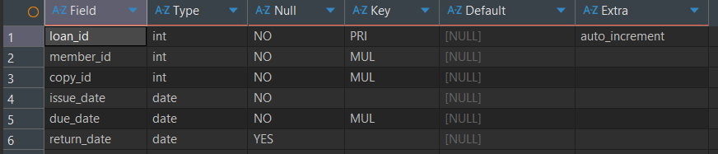

Table Name: member
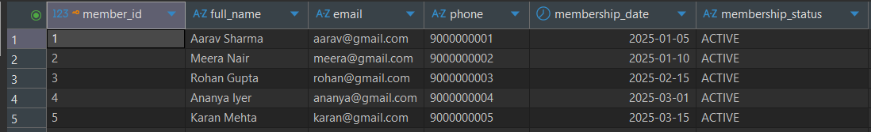

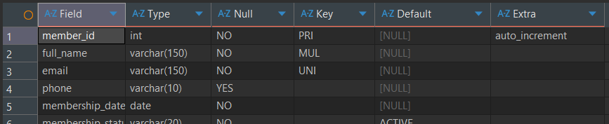

Table Name: publisher
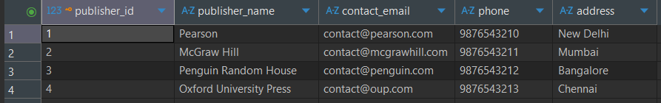

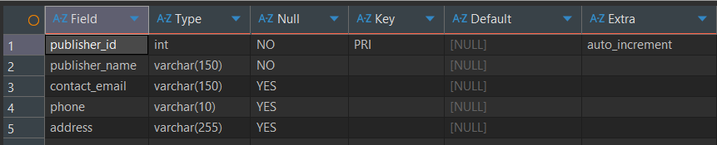

Table Name: reservation
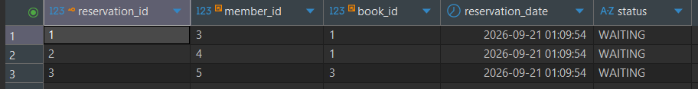
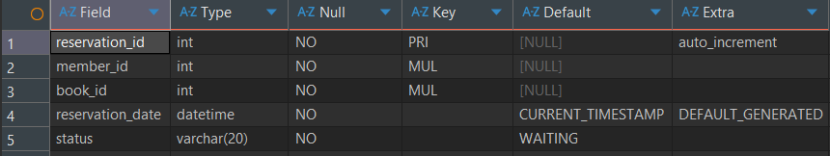

SQL Implementation

- Basic
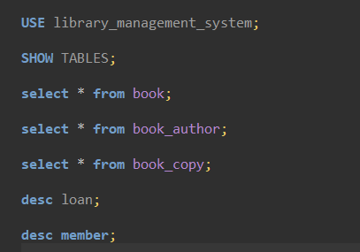

- Aggregrate












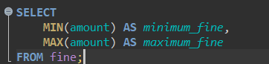



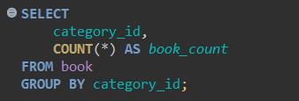

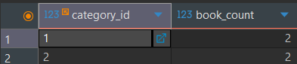

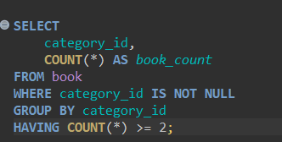

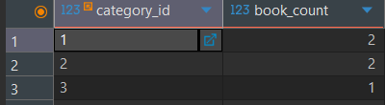

- Joins
Inner join
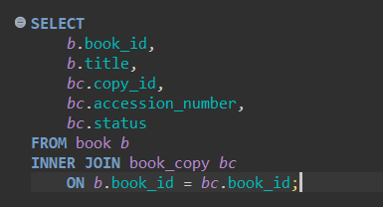
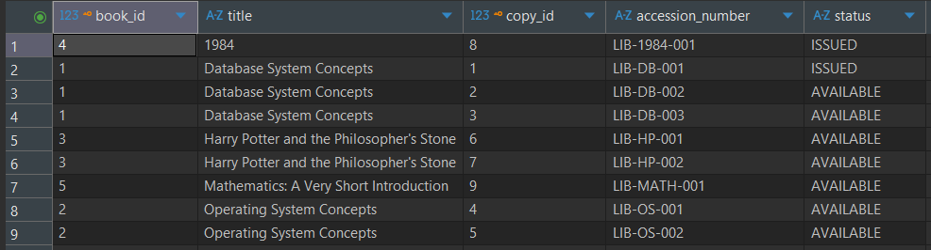

Left join

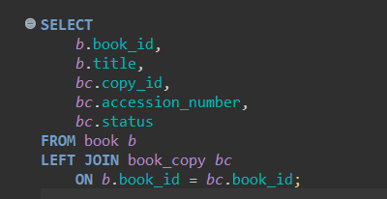
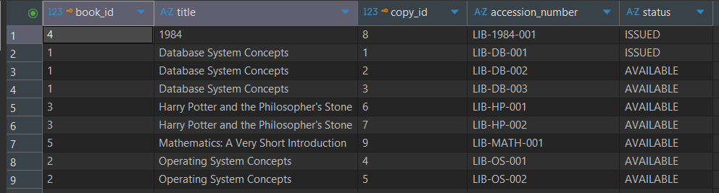

Right join

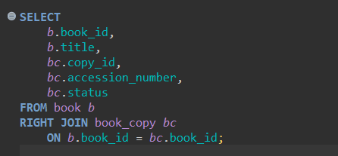
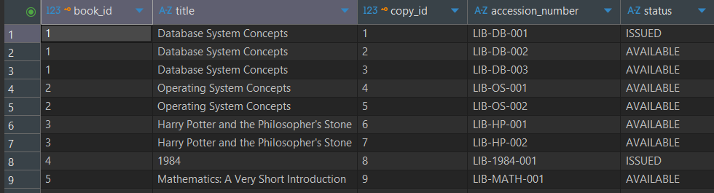

Self join

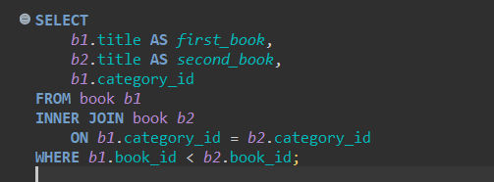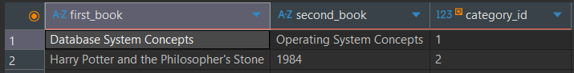

Cross join

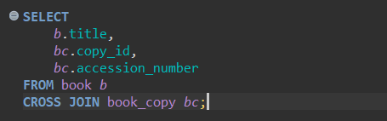
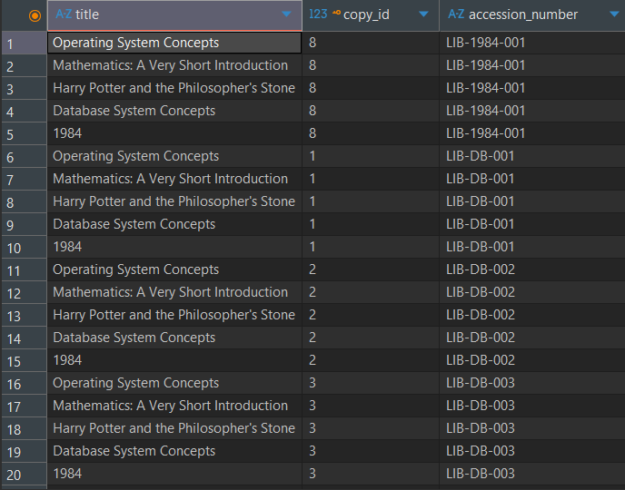

- Subqueries

Scalar subquery- Books in the most common category
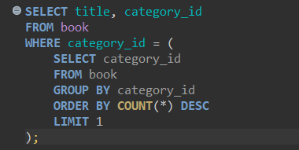
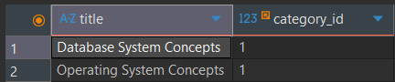

Single-row subquery-Books in the same category as book 1

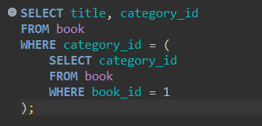
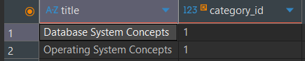

Multi-row subquery using IN- Books in categories with multiple books
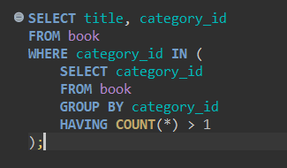
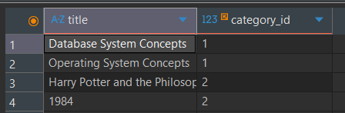

Multi-row subquery using ALL- Books in the highest category ID
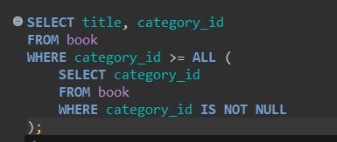


Correlated subquery — Books in above-average-sized categories
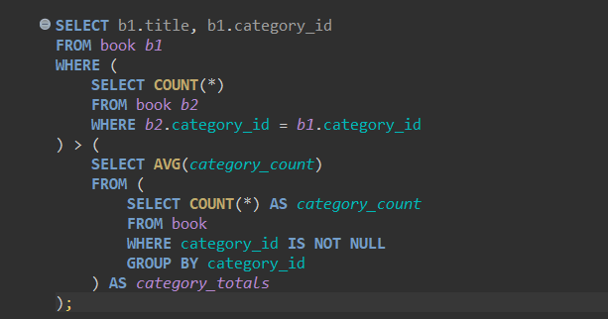
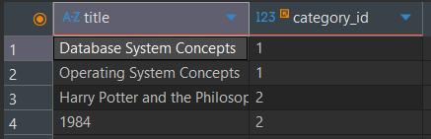

EXISTS- Categories containing books
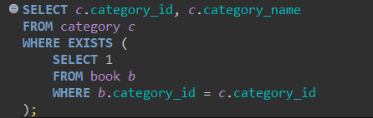
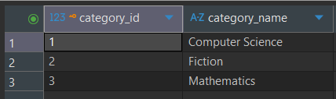

- Set Operations

UNION- Combine book titles and author names
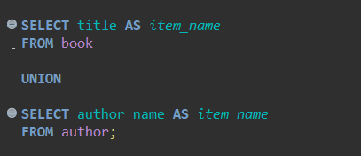
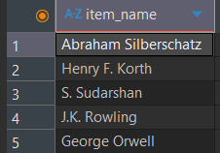

UNION ALL- Combine member names and author names
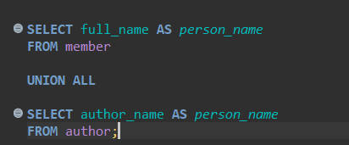
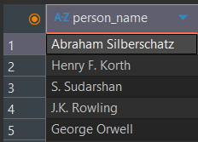

INTERSECT equivalent- Find books that have reservations
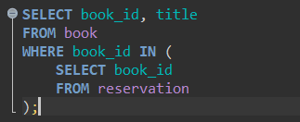


EXCEPT equivalent — Find books that have never been reserved
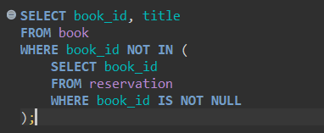
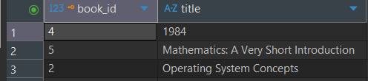

- Advanced functions

CASE- Classify book copies by availability
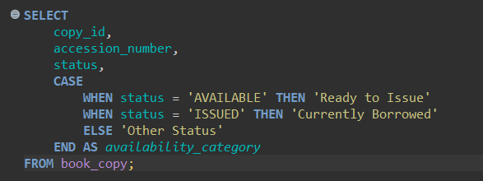
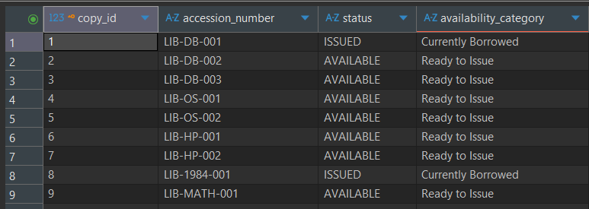

COALESCE- Display missing phone numbers
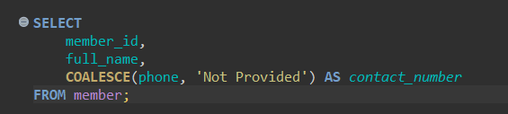
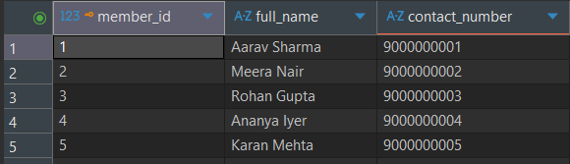

NULLIF- Handle zero fine amounts
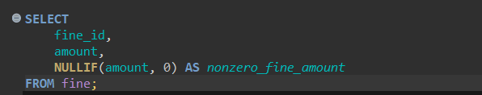


Date/time function- Calculate loan duration
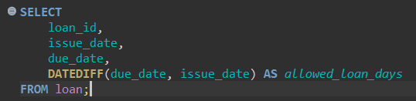
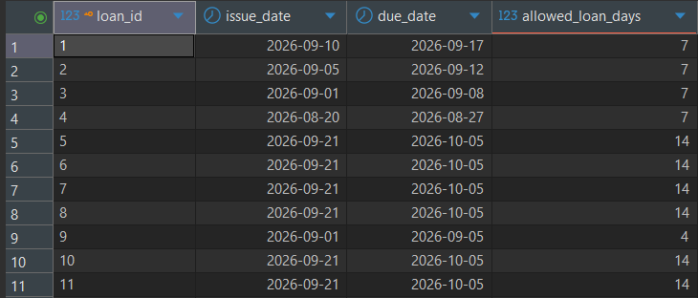

String functions- Format member names
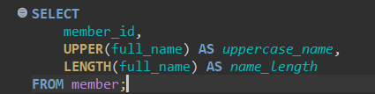
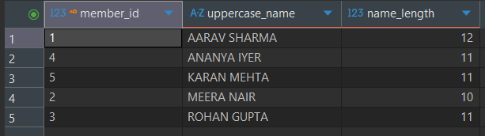

- Window/analytic

RANK()- Rank book categories by number of books
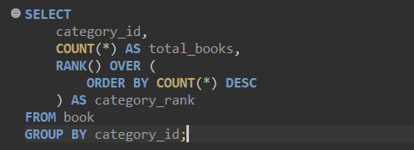
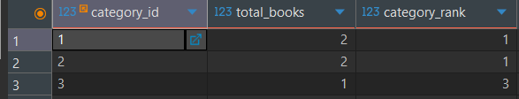

ROW_NUMBER()- Number books within each category
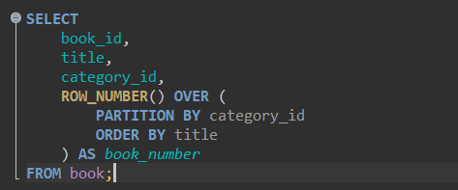
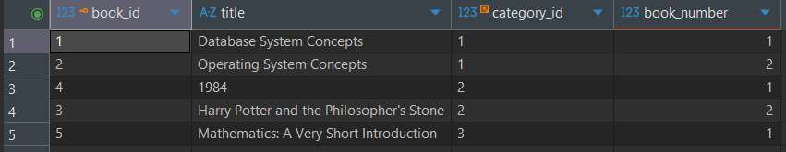

LAG() — Compare a fine with the previous fine
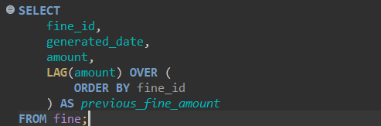
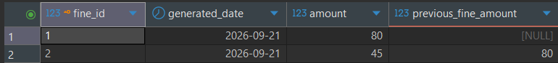

Advanced SQL Implementation
- Complex Business Queries

CQ-01: Complete book catalogue
Business question: Can the librarian view every book along with its category, publisher, and number of physical copies?
SQL:
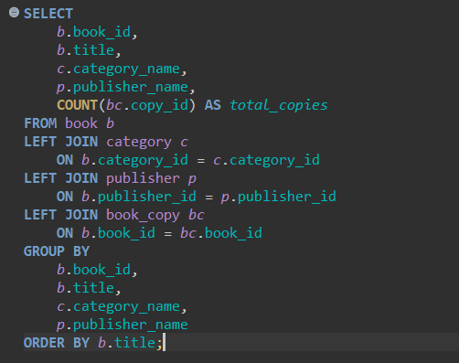
Expected output: One row per book, showing its title, category, publisher, and total physical copies. A book without recorded copies will have a count of 0. Missing publisher information will appear as NULL.
Actual output: 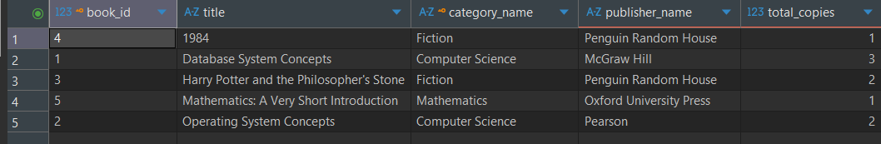
Explanation: The query joins four tables. LEFT JOIN preserves books even if their publisher or physical-copy records are missing. COUNT(bc.copy_id) counts the copies associated with each book, and GROUP BY produces one result per book.

CQ-02: Member borrowing history
Business question: Which books has each member borrowed, and when were they issued and due?
SQL:
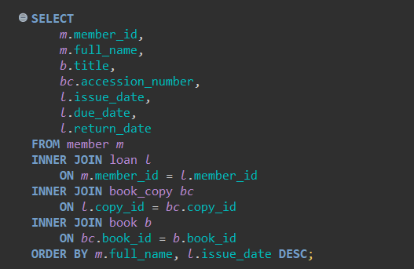
Expected output: One row per recorded loan, including the member's name, book title, copy accession number, issue date, due date, and return date. An unreturned book will have a NULL return date.
Actual output: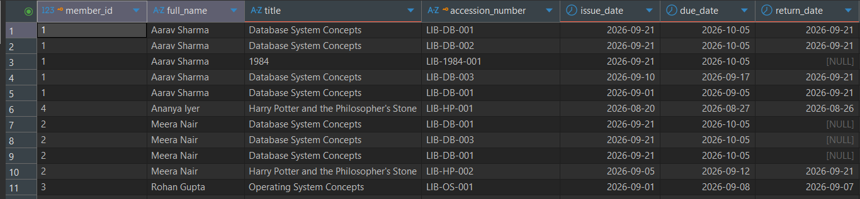
Explanation: Four tables are joined using the foreign-key relationships. INNER JOIN ensures that only loans with matching members, copies, and books are returned.

CQ-03: Currently overdue loans
Business question: Which members have books that are overdue and have not yet been returned?
SQL:
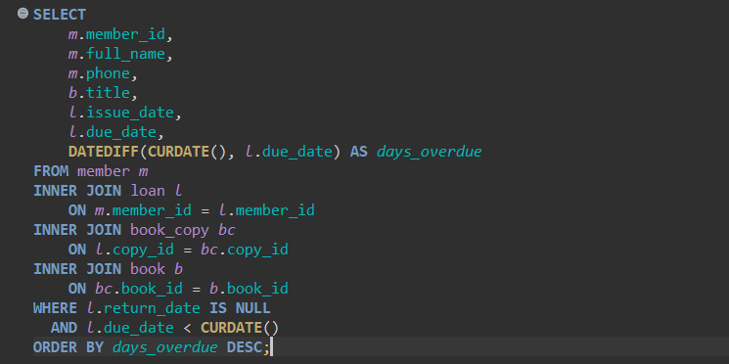
Expected output: Only loans whose due dates have passed and whose return dates are NULL. days_overdue shows the number of days past the due date.
Actual output: 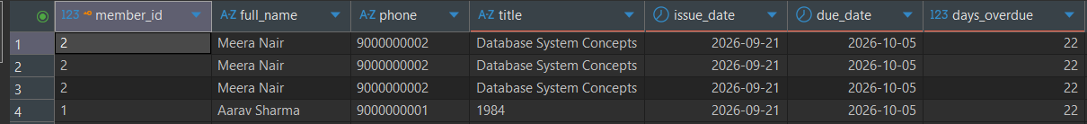
Explanation: Four tables provide member and book information. The WHERE clause filters out returned books and loans that are not yet overdue. DATEDIFF() calculates how late each loan is.

CQ-04: Unpaid fines with member and book details
Business question: Which members have unpaid fines, and which borrowed books are associated with those fines?
SQL:
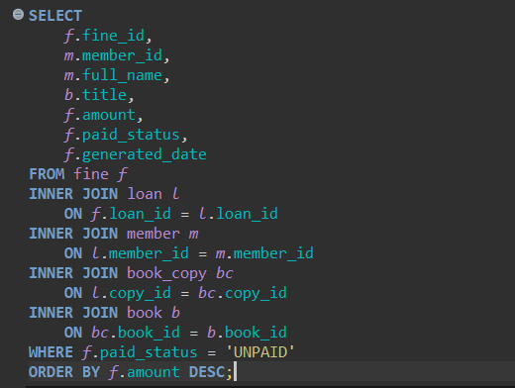
Expected output: Unpaid fine records with the responsible member, associated book, fine amount, and generation date. The highest amounts appear first.
Actual output:
Explanation: Five tables connect fine records to their loans, members, physical copies, and books. The WHERE clause selects only records marked UNPAID.

- Views
View1- Complete Book catalogue

Purpose: Provide a simplified catalogue containing book details, category, publisher, and physical-copy information.

CREATE VIEW statement
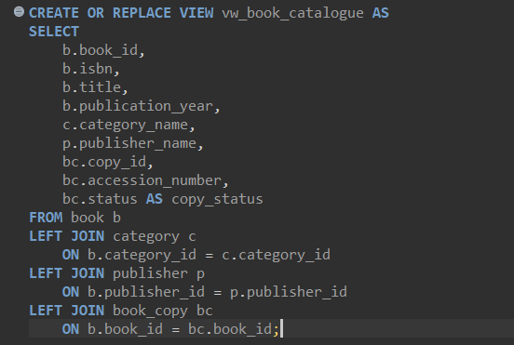

Query using the view
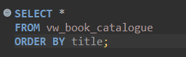

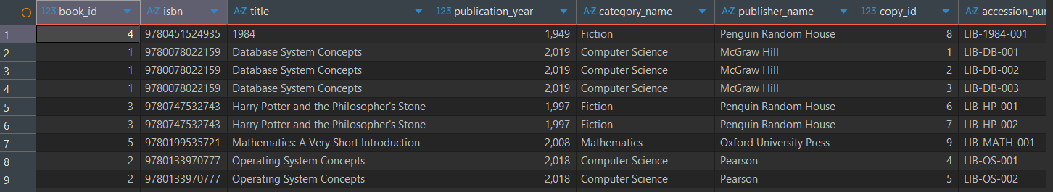
Screenshot

Why useful and is it updatable?
The view simplifies reporting by combining information that would otherwise require several joins.
Updatability: This view is generally not updatable as a whole because it joins multiple tables. The presence of joins can restrict updates through the view, and a single view row may correspond to multiple physical-copy rows.

View 2- Category inventory summary

Purpose: Summarize the number of books and physical copies available in each category.

CREATE VIEW statement
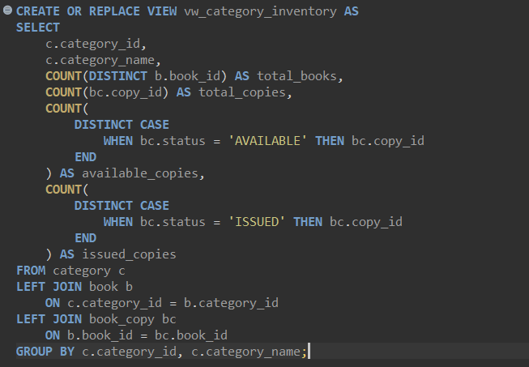

Query using the view
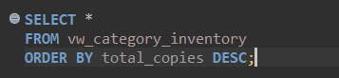

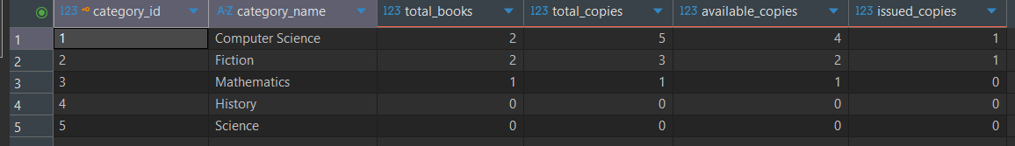
Screenshot:

Why useful and is it updatable?
This view helps librarians monitor inventory and compare categories without repeatedly writing aggregate queries.
Updatability: Not updatable. It contains aggregate functions and GROUP BY, so it represents summaries rather than individual base-table records.
Important: This assumes your copy-status values include AVAILABLE and ISSUED. If your database uses different values, update the two conditions to match the actual statuses.

- Stored Procedures
Procedure 1: Search Books by Title
Purpose: Allow a librarian to search the catalogue using all or part of a book's title.
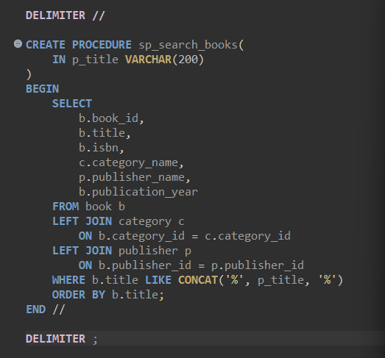
Execute the procedure

Output

Procedure 2: Get a Member's Borrowing History
Purpose: Retrieve all loans associated with a specific member.
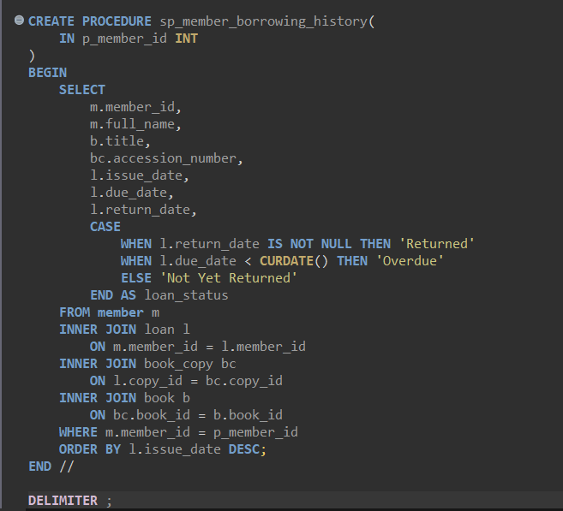

Execute the procedure

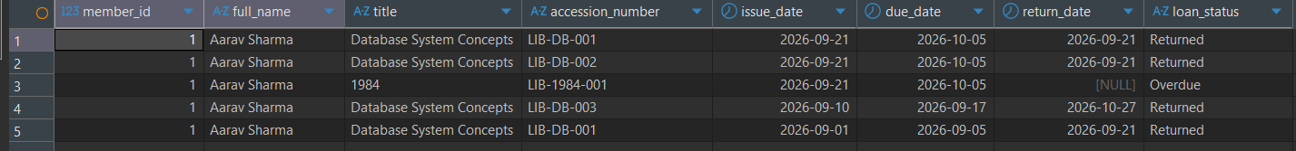
Output:

- User-Defined Functions (at least 2)

UDF-01 — Calculate overdue days
Business question: How many days overdue is a loan, based on its due date and return status?
The function returns 0 if the book is not overdue. For an unreturned book, it compares the due date with today's date; for a returned book, it compares the due date with the return date.
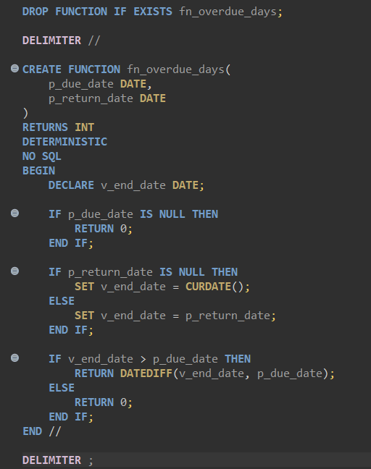
Test the function
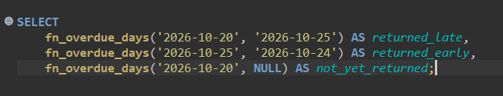

Output:


Using it with your actual loan records
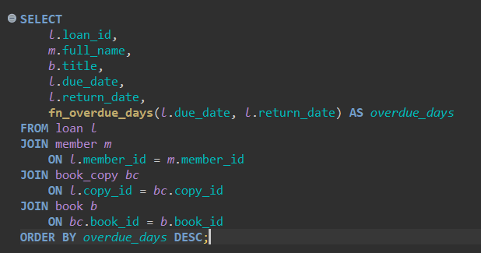
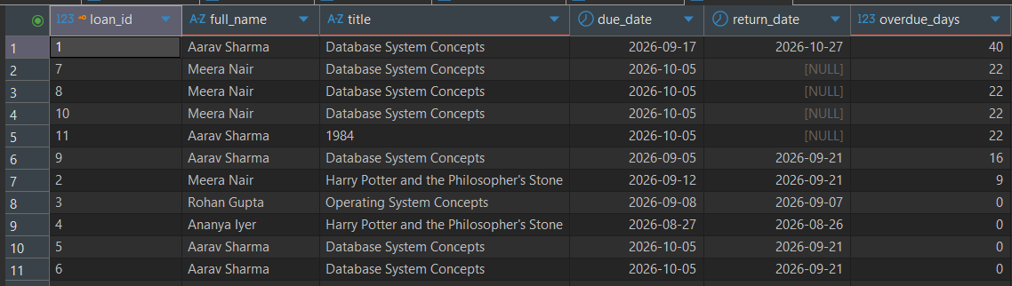

UDF-02 — Calculate a member's total unpaid fines
Business question: How much money does each member currently owe in unpaid fines?
This function uses your existing fine and loan tables and returns the sum of a member's unpaid fines.
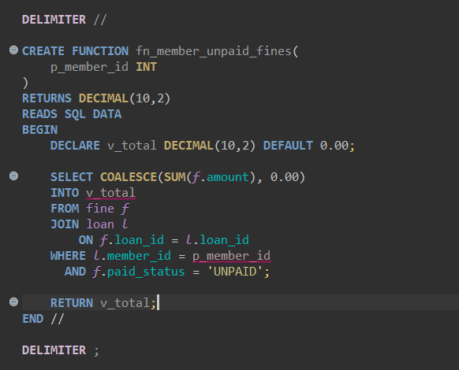
Test the function
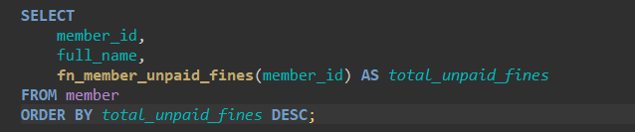

Output
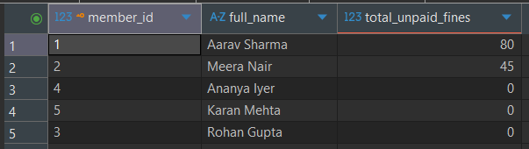

- Triggers (at least 2)
Trigger 1: Automatically update book-copy status when a loan is issued
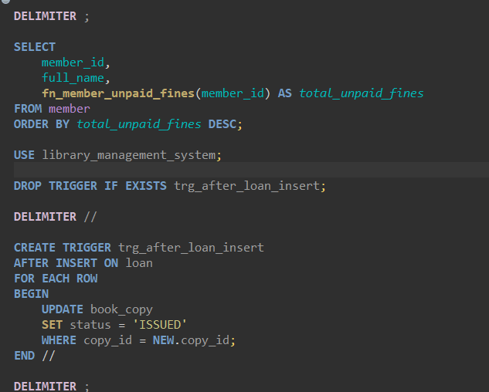

Trigger 2: Automatically mark a book copy as available when a loan is returned
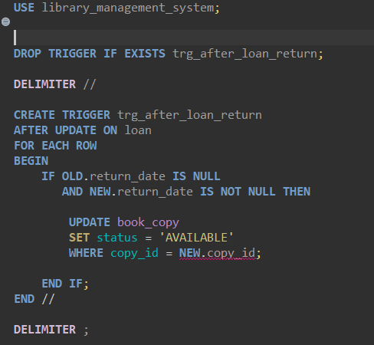

- Cursor (at least 2)
Cursor 1: Generate a list of overdue loans
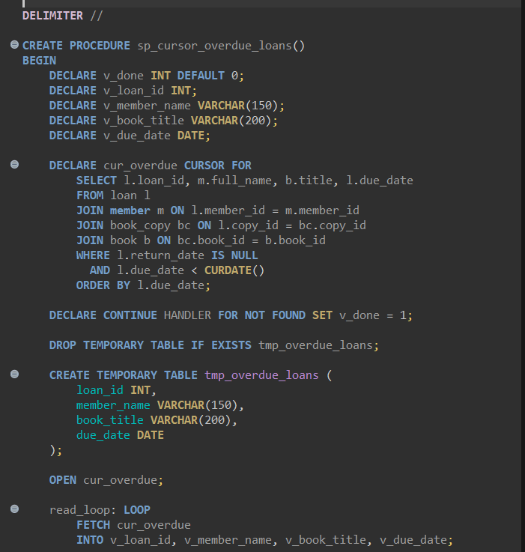
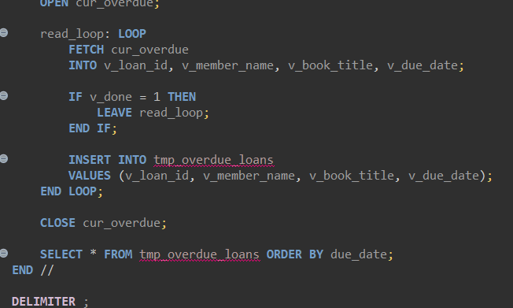

Output:

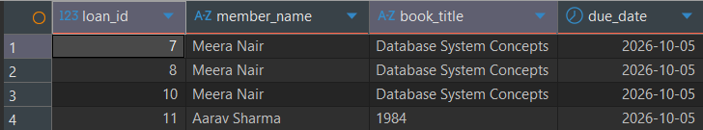

Cursor 2: Calculate total loans for each member
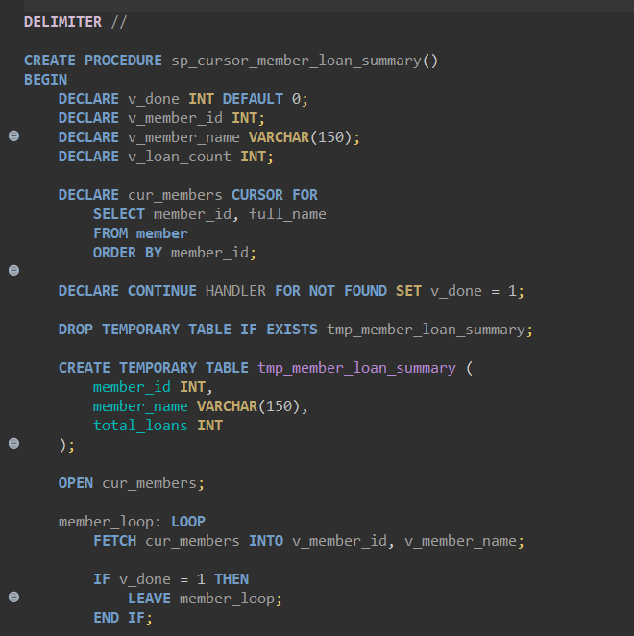
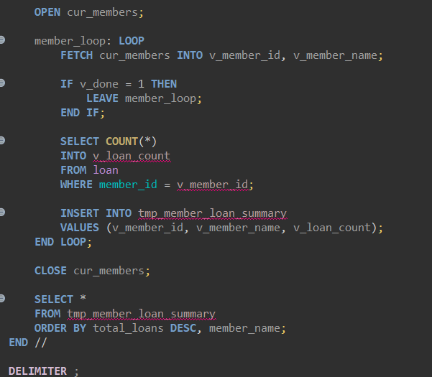

Output:
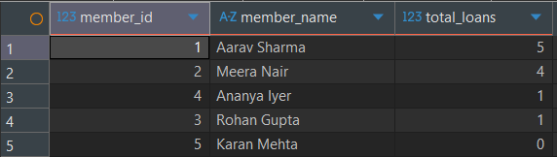

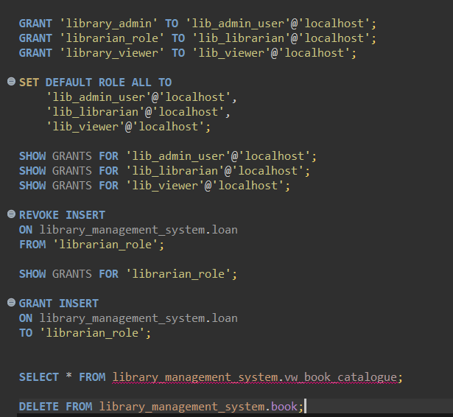
- SQL Security Implementation
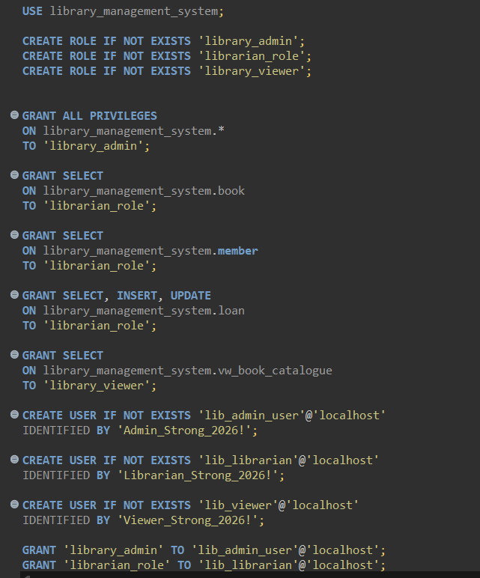

- Review 2 Requirements (checklist)

# | Mandatory component | Evidence | Status
1 | CREATE TABLE scripts + all constraints | 01_ddl.sql runs cleanly | Done
2 | INSERT, UPDATE, DELETE | 02_dml.sql, row-count table | Done
3 | Basic, aggregate, join, subquery, set-operation queries | ≥ 20 queries at this stage | Done
4 | Views | ≥ 2 | Done
5 | Transactions (COMMIT/ROLLBACK/SAVEPOINT) | Demonstration script | Done
6 | Procedures/functions | ≥ 1 each working | Done
7 | Triggers | ≥ 1 working | Done
8 | Indexes + one EXPLAIN comparison |  | Done
9 | Execution screenshots | With SQL | Provided
10 | Design changes since Review 1 | Change log with reasons | Refer below

Change Log
Change | Reason
Created views for the book catalogue, category inventory, and active members. | Simplify frequently used queries and provide controlled access to selected data.
Added stored procedures for book searches, member borrowing history, and reservations. | Reuse common operations and centralize database logic.
Added user-defined functions for calculating overdue days and unpaid fines. | Automate calculations and reduce repeated SQL logic.
Added database roles for administrators, librarians, and viewers. | Apply role-based access control and restrict unauthorized operations.
Added cursor-based procedures for overdue-loan processing and member loan summaries. | Demonstrate row-by-row processing for reporting tasks.

Work break down
Team Member Registration Number | Name | Work Assigned
24BCI0113 | Sriijta Kumar | DDL and constraints, INSERT/UPDATE/DELETE operations, basic SQL queries, joins, aggregate queries, catalogue view, stored procedures, triggers, indexes, EXPLAIN comparison, transaction management, and screenshots for assigned SQL tasks.
24BCI0116 | Kopal Joshi | Subqueries, set operations, complex business queries, inventory and active-member views, user-defined functions, SQL security and role permissions, cursor procedures, output verification, screenshot organization, and change log documentation.

REVIEW EVALUATION
COMPONENT | MARKS | MEMBER 1 | MEMBER 2
TOTAL | 10 MARKS

